The Sensory System
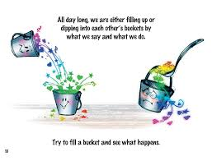

If the sensory system were a set of cups, each of them representing one of the EIGHT senses (Sight, Smell, Hearing, Taste, Touch/Tactile, Proprioception, Vestibular, Interoception), the goal would be to keep them all at just the right level of fullness which helps calm and regulate the body.
- Having too much stimulation in one cup can cause it to overflow and would send a child into dysregulation. Once one cup is out of balance, it is likely the others will overflow as well. The effect of that is a downward spiral of emotions, concentration, and patience.
- The same holds true for cups that are under filled. Unless a child receives the appropriate amount of sensory stimulation, the cup will be under filled and can cause a child’s attention and focus to be diverted to filling that cup to a more comfortable level.
- During a typical day, the sensory cups can be bombarded and under filled all at the same time which makes for a really rough day.

Try learning, listening, or even looking like you’re listening when all your mind can think about is how uncomfortable the chair is, how bright the lights are, or how many other kids are crinkling their paper causing a noise that can’t be blocked out. It is virtually impossible for a kid to learn when the sensory system isn’t regulated.

What you can do to help children with sensory processing difficulty:
- Make it predictable
  - Create routines that kids can rely on
  - Talk about the events before they occur
  - Provide plenty of options
- Make it playful
- Add sensory activities to your daily routines
- Don’t sweat it if it does not always work
  - Some days are better than others
  - Children’s sensory needs vary and can change

Examples of…

Calming Sensory input:
- Heavy work: “tasks that involve heavy resistance for the muscles and joints. It involves proprioceptive input, the awareness of posture, movement, and resistance relating to the body.”
- Proprioception/Deep pressure:
  - Heavy work
  - Squeezing – playdoh, sponges, spray bottles
  - Vibration

- Vestibular (movement sense):
  - Slow, rhythmic
  - Rocking – laundry basket, rocking chair, sitting on lap
  - Moving forward/backward – riding in a wagon, riding a tricycle
  - Swinging in a blanket
- Tactile
  - Water play, beans, rice, sand, playdoh, putty
- Visual
  - Glitter in a water bottle
  - Calming sensory bottles
- Auditory
  - Rain stick, calming music, white noise, music/singing
Alerting Sensory Input:
- Proprioception:
  - Vibration (handheld massager, vibrating toothbrush)
  - Animal walks (bear walk, frog jump, snake walk, dinosaur stomp, crab walk)
  - jumping
- Vestibular:
  - Spinning
  - Fast movement
  - Jumping, running, climbing
- Tactile
  - Messy play – paint, shaving cream, slime, food exploration
- Visual
  - Bright lights, contrasted colors
- Auditory
  - Music, singing,

There are TONS of ideas to try


Morning

- Start with stretch – Legs/arms out, hold for 10 seconds and legs/arms in. repeat 2-3 times while taking big breaths
- Give deep pressure/bear hugs, hand hugs before getting dressed
- Vibrating tooth brush, silly faces in mirror, massage cheeks
  - If sleepy or not awake, splash a little water on face. Wash hands/face
- Jumping or animal stomps when getting dressed to put socks on
- Put clothes in dryer for a few minutes so clothes are warm and cozy
- Massage/squeeze each body part before putting clothes on (squeeze feet put socks on; squeeze legs put pants on)
- Drink water/smoothies through a straw
- Crunchy breakfast
- Clean dishes with a towel, pour water on top
- Push chairs in kitchen table
- Take the garbage out
- For CORE STRENGTH:
  - read a book, color, do a puzzle in prone
  - bridges – drive cars underneath – don’t squish the cars!
  - Crawling – use a tunnel, crawl under chairs
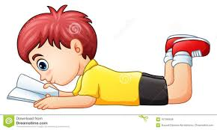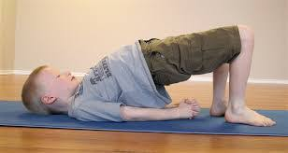


Afternoon
- Tug of war in standing or sitting – pulling gives calming sensory input, works on core strength
- Pillow tower/pillow sandwich – deep pressure and soothing/calm voice
- Carry a pile of books/cans – give a specific place to put them
- Help push the garbage tin
- Carry laundry basket, take laundry out and put in drawers, then use basket to pretend it’s a boat. Give rocking input for calming. Increase to alert by pretending there is a storm
- CORE STRENGTH:
  - Wheelbarrow walks
  - Crab walk soccer – kick the ball while walking like a crab
  - Superman
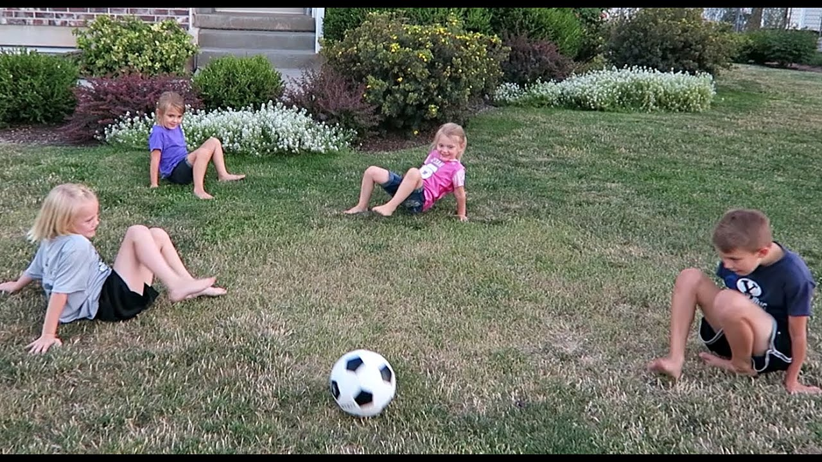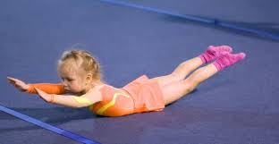
- Set up table – pour milk/water with support
- Help stir
- Push chairs in/out
- Wipe/clean the table with spray bottle, and rag

Late Afternoon/ Evening:
- Wall pushes – “try to push the wall over!”
- Army crawls – no knees allowed!
- Carry buckets of water, milk, pasta
- Dig in the dirt/sand
- Rip paper/cardboard
- Push laundry basket, and go “shopping” – make it heavy!
- Push, move, drag furniture
- Play with tiles
- Rolling in a blanket – with firm pressure provided on back, use soothing quiet voice to calm
- Calming music

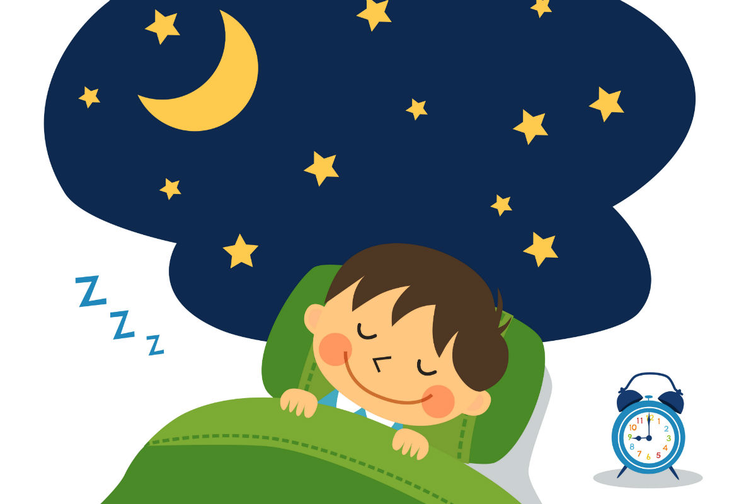
Bedtime Routine

- Wind-down at least 1-2 hours before bed time
- Avoid bright screens, or excess stimulation that is distracting (Toys, loud music)
- Relax in dim, quiet space
- Choose relaxing activity like reading, puzzle, word/number games – on tummy
- Provide calming music (ocean sounds, classical music, white noise machine sound)
- Wrap tightly in a blanket
- Warm bath, lotion with deep, firm pressure/massage while labeling body parts
- Lavender/chamomile scents
- Light yoga poses – down dog, cobra, curl into a ball
- Tight hug from family member, or roll a ball on top of back
- Laying upside down
- Deep breaths, sucking
  - Drink water through a straw
- Rhythmic motion:
  - Gentle rocking or swinging in blanket or in arms
  - Hold in lap – sway side to side while singing
**Stop fast movements (running, jumping, spinning,) 2-3 hours before bedtime

Lianna Raspudic MS, OTR/L

